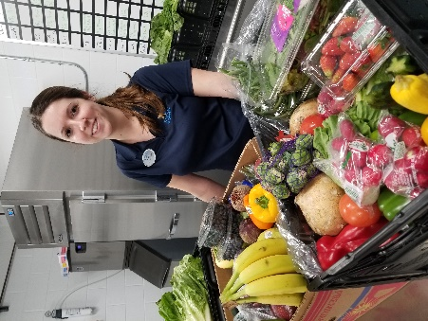

Roxie Miller
Husbandry Assistant, Commissary Keeper

How long have you worked in this job?
The Texas State Aquarium approached me in February 2016 after receiving my degree in marine biology when I was then a volunteer with the dive team. They asked if I would like to help open the new commissary for Animal Care here.

What does it take to get a job like yours?
I have a degree in marine biology and am also in the process of receiving certifications in nutrition as well.

What is your favorite part of your job?
I like working with all three major branches of the aquarium: Dolphin Bay, Caribbean Journey, and the Wet Area behind the scenes of the Gulf of Mexico.

What is the most challenging part of your job?
It is difficult to oversee four kitchens (Dolphin Bay, Caribbean Journey, Gulf of Mexico and Sea Lab) that operate almost daily. The amount of work that goes into maintaining these four kitchens to meet USDA standards, AZA standards, and making sure the highest standards of care are surpassed here at the Texas State Aquarium.

Do you have any memorable stories to share?
Preparing for the storm, Hurricane Harvey, to push onto shore was a major challenge. We had to make sure we had enough food for the entire aquarium prepped and ready to use in case there were multiple days/nights without power. Luckily, the Caribbean Journey generator kept running the entire time, so being completely without power was never an issue. Housing and feeding so many animals in one area, keeping their diets separate and high quality, was a bit overwhelming at times though. It takes roughly eight hours to prep for one day’s worth of food, so having to prep for multiple days at once was a lot. I don’t think they had any idea of what was ahead of them before the storm hit.

